Auckley School Educational Visits Journey

Your Physical Education Journey starts here …
Year
5

Kings and Queens workshop

Rugby

Cinema Trip
PGL Residential – Newby Whiske

WW1 Workshop
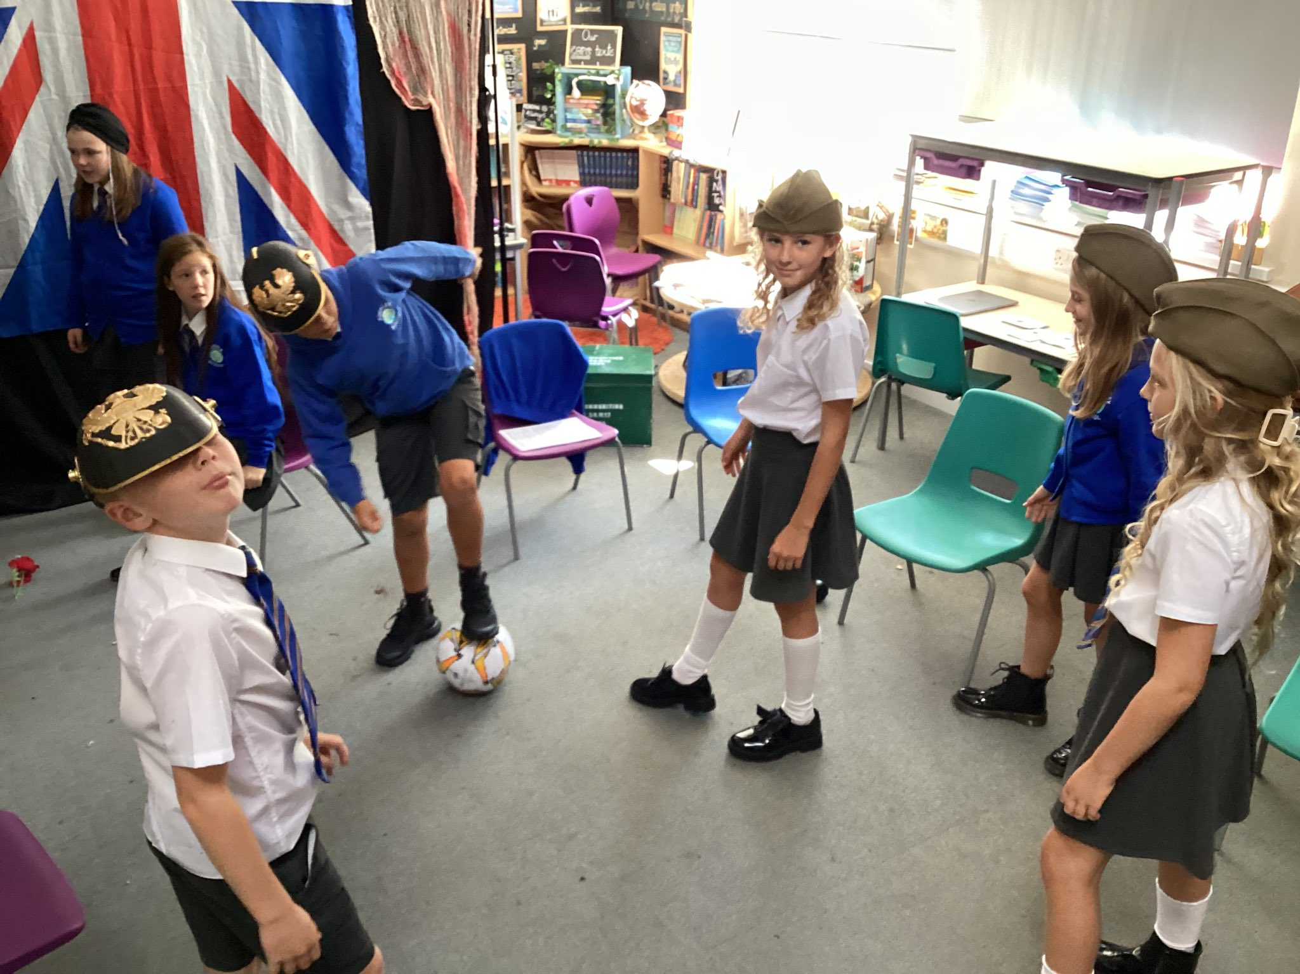
National Holocaust Museum

Crucial Crew

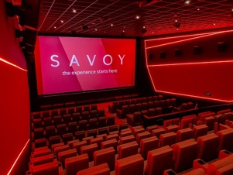
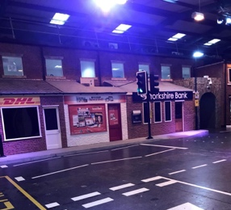
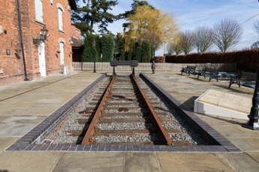
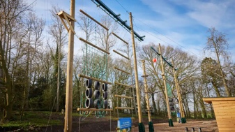
Multi year group Experiences
- Diwali Dance Workshops
- Whole school art days with Emma Bairdstow
- Creative Arts Week
- KS2 Judaism Workshops
- Whole School Christmas Pantomime
- Ramadan celebrations
- Community Careers Day
- VR workshops

Jamia Mosque

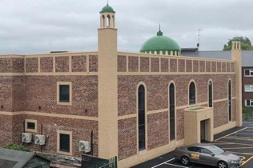

Year
6

Whole school events and competitions

Austerfield Residential
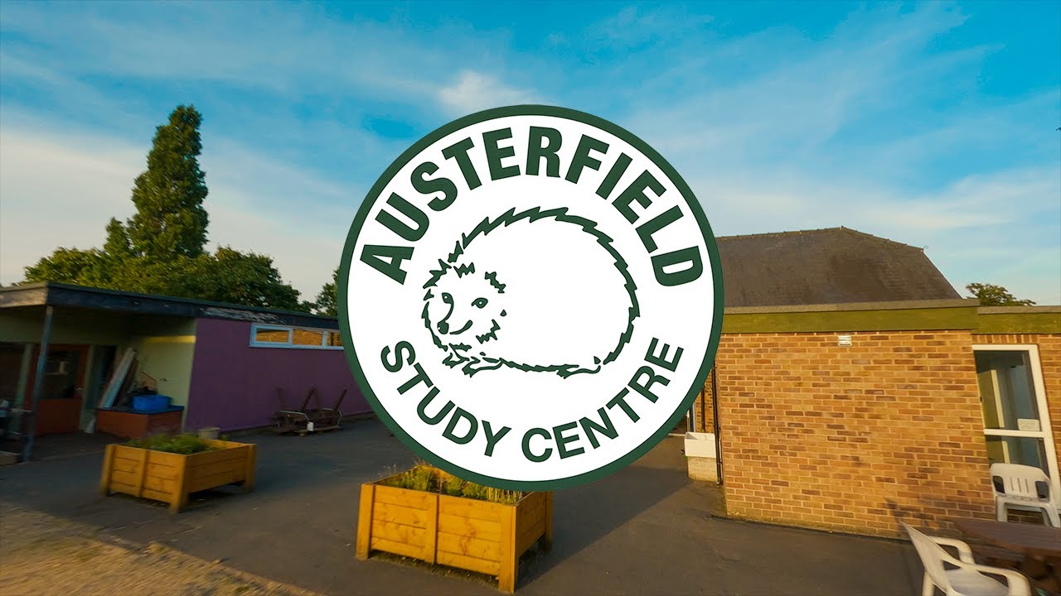

USA Workshop

Mayan Workshop

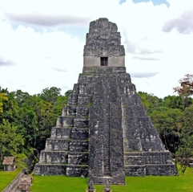
Roman Workshop

Hull Museum

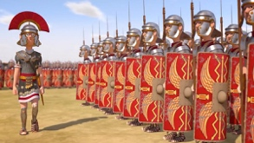
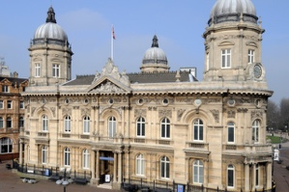

Kelham Island
Murton Park
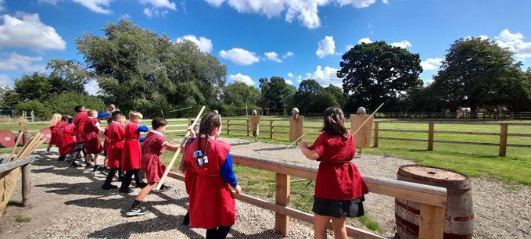
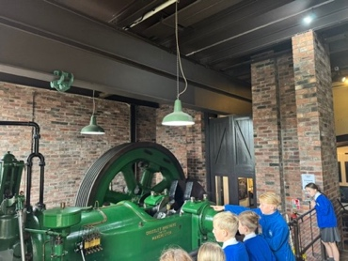

Murton Park

Doncaster City Tour

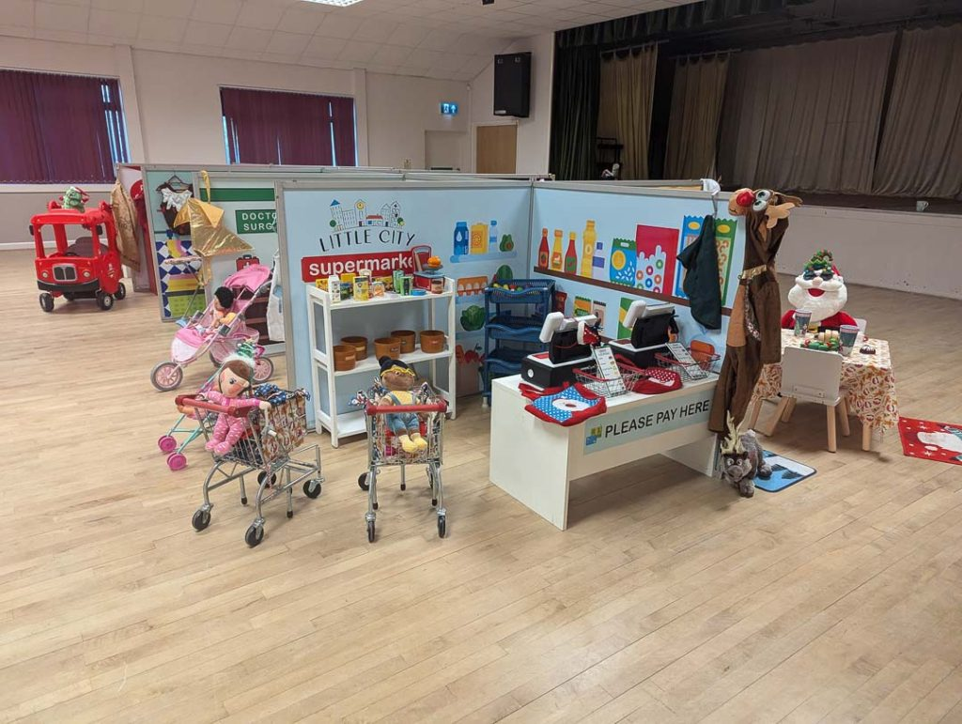
Austerfield Trip
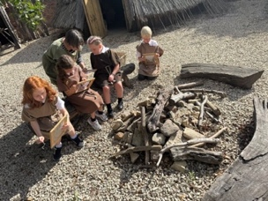
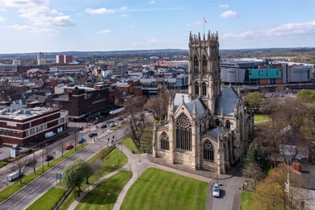
Yorkshire Wildlife Park
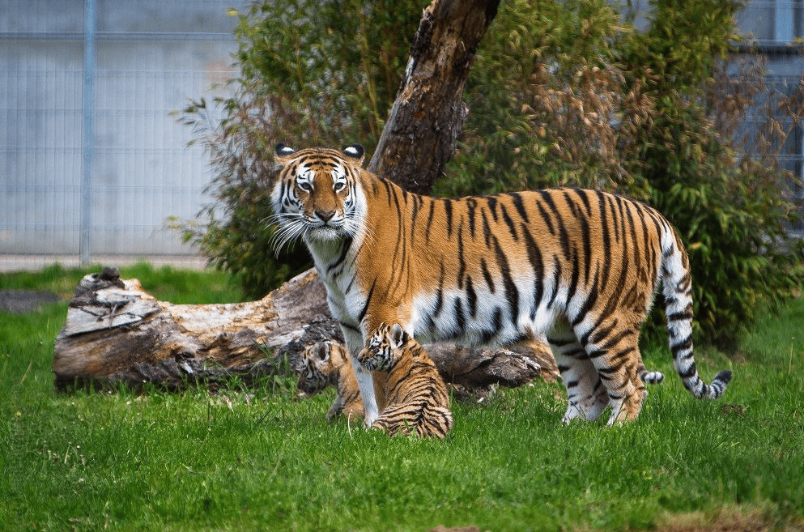

National Justice Museum

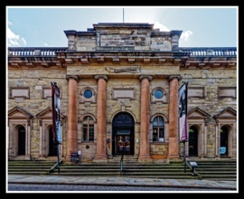
Year
4

Year
3

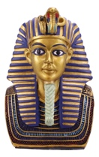
Egyptian
workshop
Tropical butterfly house

Seaside visit & workshop

Local Walk

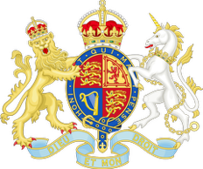
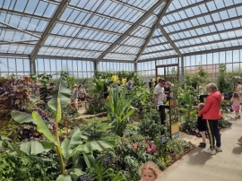
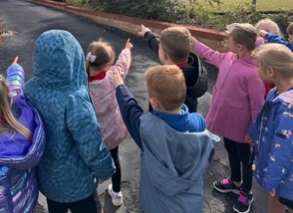
Toy Museum
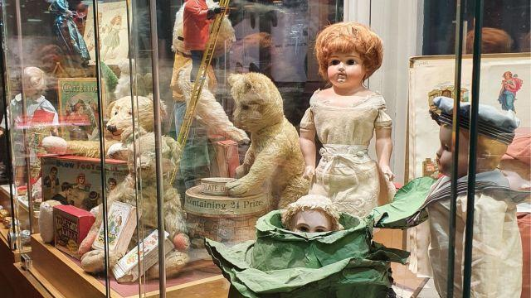
Little City Workshop

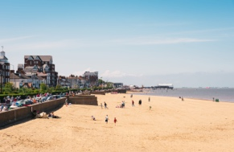
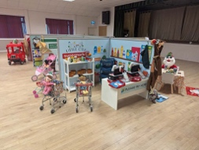

Year
2
Year
1
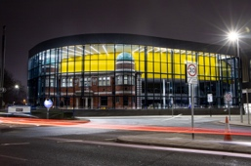
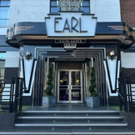
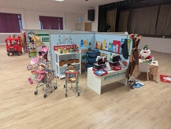
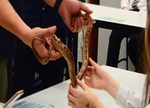
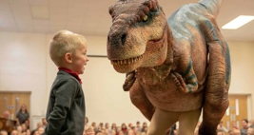
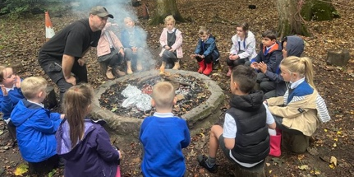
Doncaster
Museum

Afternoon Tea at The Earl of Doncaster

Little City Workshop

EYFS

Zoo lab

Teach Rex Workshop
Doncaster Fire Station & Sandall Beat Wood

